Simulation of 5G-nr MAC protocol using MATLAB

Introduction on 5g new radio interface

The 5G-NR data link layer is a crucial component of the 5G radio interface, ensuring reliable and efficient communication between user equipment (UE) and network infrastructure. According to the document, 5G-NR introduces advancements over LTE by incorporating flexible frame structures, multiple subcarriers spacing (SCS) options, and improved error correction techniques. The data link layer consists of sublayers such as MAC (Medium Access Control), RLC (Radio Link Control), PDCP (Packet Data Convergence Protocol), and SDAP (Service Data Adaptation Protocol). These layers collectively handle error correction, QoS management, security, and resource allocation in a dynamic 5G environment.
Key features of 5G-NR data link layer include adaptive scheduling, hybrid automatic repeat request (HARQ) improvements, and enhanced MIMO capabilities for OSbetter spectrum efficiency. The radio link monitoring (RLM) and radio resource management (RRM) ensure stability, while coexistence with LTE allows for a smooth transition from 4G to 5G.

📡 5G Protocol Layers and Uplink Transmission (UE → gNB)
1. 5G User Plane Protocol Layers
The user plane in 5G consists of four main protocol layers between the UE (User Equipment) and gNB (next-gen base station):
Layer | Role | Key Functions
SDAP (Service Data Adaptation Protocol) | QoS Flow Management | Maps QoS Flows to Data Radio Bearers (DRBs), adds QFI
PDCP (Packet Data Convergence Protocol) | Security & Reliability | Encryption, integrity protection, header compression, reordering
RLC (Radio Link Control) | Segmentation & Retransmission | Splits/reassembles packets, supports ARQ in Acknowledged Mode
MAC (Medium Access Control) | Scheduling & Multiplexing | Handles uplink/downlink scheduling, HARQ, multiplexes RLC data

2. Uplink Transmission Flow (UE → gNB)
When a UE wants to send data (e.g., upload or send a message), the transmission occurs in the following sequence:
- SDAP assigns the appropriate QoS flow.
- PDCP encrypts and compresses the data.
- RLC segments the data and ensures reliability.
- MAC waits for uplink resources from gNB and prepares the data for transmission.
- PHY layer transmits the signal over the air to the gNB.
The gNB then performs the reverse processing to receive and forward the data to the core network.

3. Uplink Scheduling Process
Uplink communication in 5G is controlled by the gNB, and the UE must request permission to transmit:
- UE sends Scheduling Request (SR) to gNB via control channel.
- gNB grants uplink resources (time, frequency, data size).
- UE transmits data over PUSCH using the grant.
- gNB responds with ACK/NACK.
- If NACK, the UE retransmits using HARQ (Hybrid Automatic Repeat Request).

Summary
The 5G user plane protocol stack ensures efficient, secure, and reliable data transmission through well-defined layers (SDAP, PDCP, RLC, MAC). Uplink transmission is resource-managed by the gNB via a dynamic scheduling system, ensuring optimal use of spectrum and QoS adherence.

Simulation:
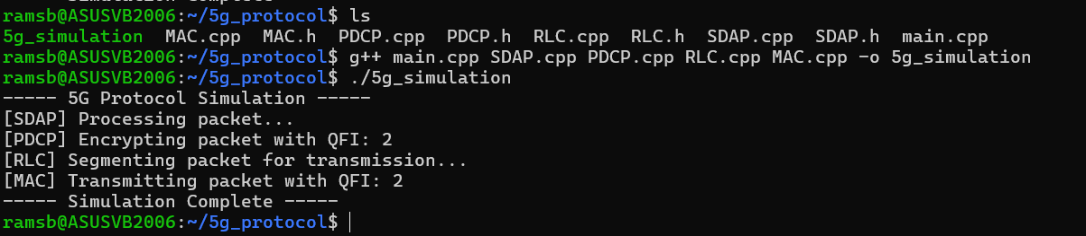
Implemented using:

Tool Purpose
1. GCC & CMake Compiling & building C++ code
2. Boost C++ Efficient networking, threading, and memory management
3. Wireshark & TCPDump Capturing and analyzing 5G protocol traffic

MAC PROTOCOL IN 5G-NR

In 5G New Radio (NR), the MAC (Medium Access Control) layer is responsible for efficiently managing data transmission between the base station (gNB) and the user devices (UEs). It acts as a middle layer between the physical layer and higher layers, ensuring that resources like time and frequency are properly allocated. The MAC layer handles important tasks such as scheduling, resource allocation, data retransmissions using HARQ (Hybrid Automatic Repeat Request), and reporting buffer statuses. It adapts to changing network conditions and user demands, ensuring that users get fair access while maintaining high throughput. Different scheduling algorithms, like Round Robin or Proportional Fair, help prioritize users based on channel quality and data requirements. Overall, the MAC protocol is a key part of making 5G fast, reliable, and flexible for all types of applications.
OVERVIEW ON FUNCTIONS PERFORMED BY MAC
Traffic Generation
- UEs generate random data packets to transmit.
- Data is stored in the UE's buffer (BSR).
Buffer Status Reporting (BSR)
- UEs report buffer size to gNB.
- Helps gNB decide how much data to schedule.
Channel Quality Update
- Channel conditions (CQI) are updated every TTI.
- Affects MCS (Modulation and Coding Scheme) selection.
HARQ Feedback Handling
- gNB receives ACK or NACK for each transmission.
- NACK → triggers HARQ retransmission.
Scheduling
- gNB decides which UEs to serve.
- Based on: buffer size, channel, retransmissions.
- Uses algorithms like Round Robin, Max Throughput, Proportional Fair.
MCS Selection
- gNB selects MCS for each UE.
- Higher MCS = more data per PRB, but needs better channel.
Resource Allocation (PRBs)
- gNB assigns PRBs to UEs.
- Allocated based on scheduling decisions and data size.
Data Transmission
- UEs transmit data using assigned PRBs and selected MCS.
- HARQ stores copies for potential retransmission.
Retransmission (HARQ)
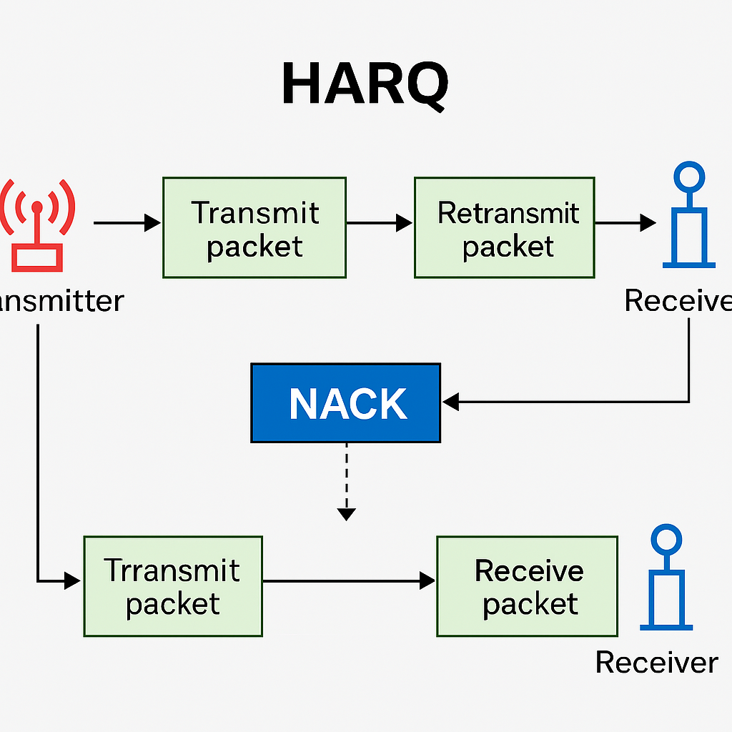
- If NACK received, data is retransmitted via HARQ.
- Limited number of retransmissions per process.

How HARQ Works (Step-by-Step):
- Transmission:
The gNB (base station) sends a data packet (HARQ process begins).
- Error Check (CRC):
The UE checks the received data using a CRC (Cyclic Redundancy Check).
- ACK/NACK Feedback:
  - If the packet is received correctly: UE sends an ACK (Acknowledgment).
  - If there's an error: UE sends a NACK (Negative Acknowledgment).
- Retransmission (if NACK):
gNB retransmits the same or similar data using incremental redundancy.
- Soft Combining:
The UE combines the original and retransmitted data to decode the packet more reliably.
- Repeat or Stop:
The process repeats until:
  - The data is decoded successfully (ACK), or
  - The maximum number of retransmissions is reached (packet dropped).
Difference between HARQ and ARQ :
ARQ (Automatic Repeat reQuest) is a basic error control method where the receiver checks for errors and requests a full retransmission if needed. HARQ (Hybrid ARQ) is a more advanced version that combines error detection with forward error correction. Instead of just resending the entire data, HARQ sends additional redundant bits and allows the receiver to combine multiple transmissions to improve decoding. This makes HARQ faster and more efficient than ARQ, especially in wireless systems like 5G.

DESCRIPTION FOR MODULES ON MATLAB :

1. loadSimulationParameters.m
Purpose:
Defines default simulation parameters like:
- Number of UEs (numUEs)
- Bandwidth part size (bwpSize)
- Simulation time (simTime)
- Scheduler type (e.g., Round Robin, PF)
- MCS table (modulation-coding)
Usage: Called first in main.m.

2. getUserParameters.m
Purpose:
Allows interactive user input to override default parameters such as:
- Number of UEs
- Simulation time
- Scheduler type
- Adaptive MCS toggle
Usage: Optional input flexibility for customized runs.

3. initializeNetwork.m
Purpose:
Initializes:
- UEs – with buffers, average throughput, and HARQ structures
- gNB – base station entity (basic)
- channelMatrix – random initial channel conditions per UE

4. generateTraffic.m
Purpose:
Adds random packet arrivals into UE buffers using a Poisson process.
Each TTI (Transmission Time Interval) may have some traffic depending on the load.

5. runScheduler.m
Purpose:
Performs UE scheduling based on buffer status and HARQ:
- Round Robin: Equal share to active UEs
- Max Throughput: Priority to best channel
- Proportional Fair: Trade-off between fairness and rate
It also selects appropriate MCS per UE based on channel quality.

6. performMACOperations.m
Purpose:
Simulates transmissions for each scheduled UE:
- If successful (based on channel quality), mark as ACK
- If failed, mark as NACK, initiate HARQ retransmission
- Update BSR (Buffer Status Report) and HARQ feedback

7. updateChannelConditions.m
Purpose:
Simulates time-varying channels, randomly updating channel quality for each UE for the next TTI.

8. visualizeResults.m
Purpose:
Generates visual output using:
- Bar charts showing ACKs, NACKs, retransmissions per UE
- Pie chart showing proportion of successful vs failed transmissions
Helps understand overall reliability and channel behavior.

9. displayPerformanceSummary.m
Purpose:
Prints a summary report in the command window:
- Total transmissions
- ACK/NACK rates
- Retransmission ratio
- Average success rate

main.m coordinates everything:
1. Load default parameters → allow user input override
2. Initialize network: UEs, gNB, channels
3. Loop over time (TTIs):
- Generate traffic into UE buffers
- Run scheduler based on HARQ & buffer status
- Simulate transmission success/failure with MAC operations
- Log ACK/NACK/Retx data
- Update channel quality for next round
4. At end: visualize results & print performance summary

Summary:
The MAC (Medium Access Control) layer is part of Layer 2 in the 5G NR protocol stack. It sits between the RLC (Radio Link Control) and PHY (Physical) layers, acting as the key traffic manager for data transmission over the air.
Think of MAC as the "air traffic controller" of 5G—managing when, how much, and what kind of data gets sent and received, based on network conditions and priorities.
The MAC layer is critical to the efficient operation of the 5G air interface. It balances reliability (via HARQ), resource allocation (via scheduling), and real-time adaptation to network conditions (via CQI/PMI reports). Its fast, lightweight design ensures that high-throughput, low-latency communication can be achieved in diverse use cases—from mobile broadband to ultra-reliable low-latency communications (URLLC).

Simulation :

GRAPHS

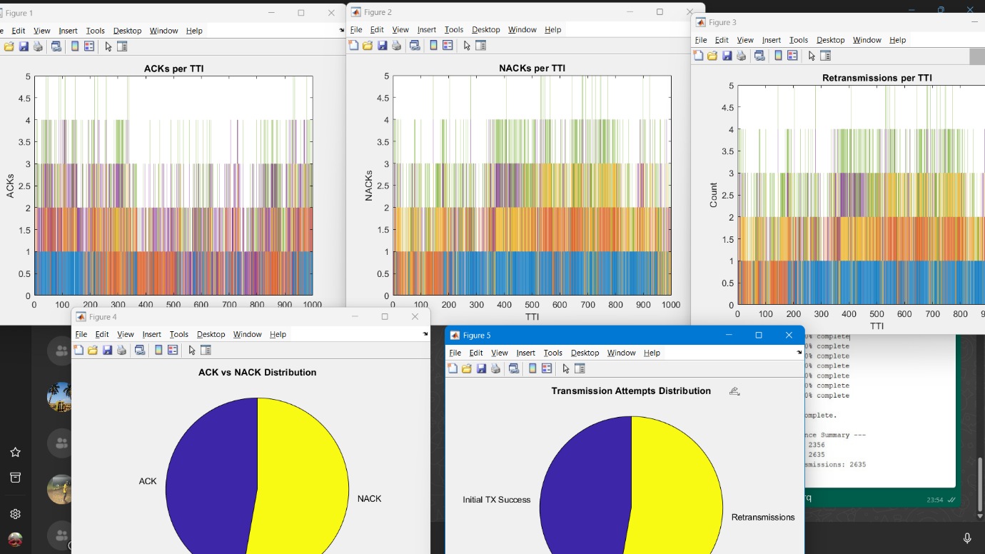

GRAPHS DESCRIPTION:
TTI :
A TTI is the time duration over which data is scheduled, transmitted, and processed in a wireless system like 5G NR.
One TTI = one iteration in the simulation loop.
At each TTI:
UEs generate traffic.
Scheduler assigns PRBs.
Data is transmitted.
HARQ feedback (ACK/NACK) is generated.

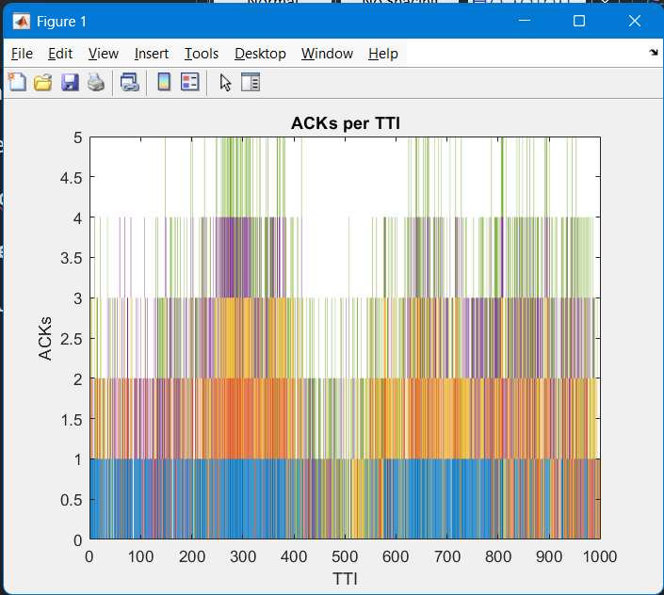
Figure 1: ACKs per TTI
- Y-axis: Number of ACKs.
- X-axis: Time Transmission Intervals (TTIs).
- Each colored bar represents a UE.
- Shows successful transmissions acknowledged by the receiver.
- A higher count = more reliable communication at that TTI.
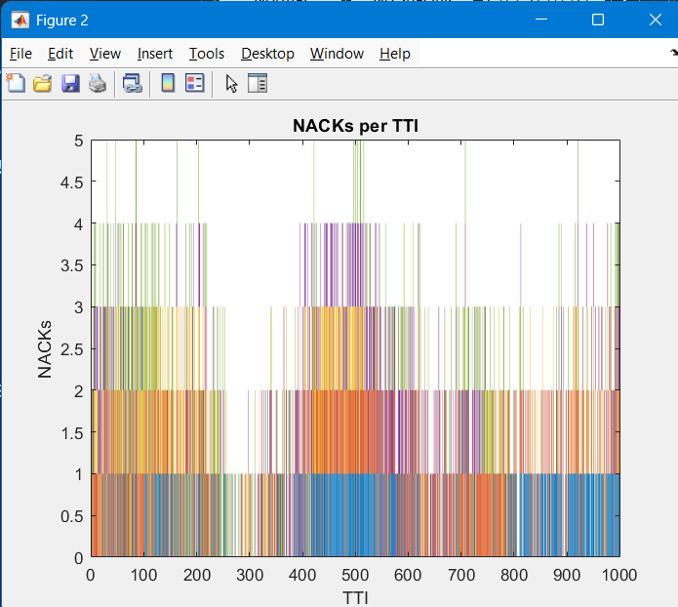
Figure 2: NACKs per TTI
- Y-axis: Number of NACKs.
- X-axis: TTIs.
- Displays failed transmissions that require retransmission.
- Helps evaluate how often UEs experience transmission errors.
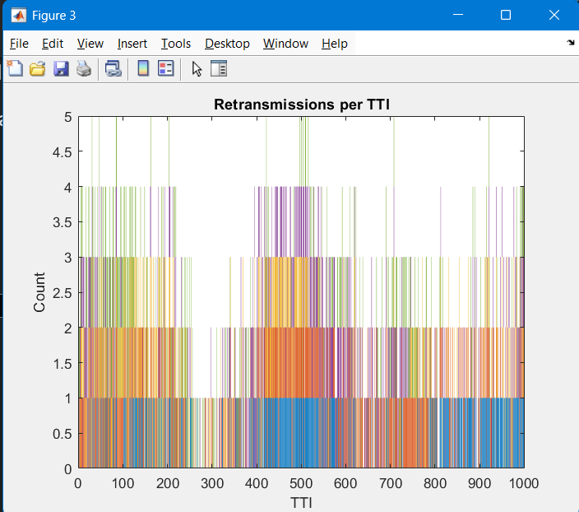
Figure 3: Retransmissions per TTI
- Y-axis: Number of retransmissions.
- X-axis: TTIs.
- Highlights the HARQ behavior: if data wasn't successfully received, it's retransmitted.
- Useful for analyzing link quality and scheduling efficiency.
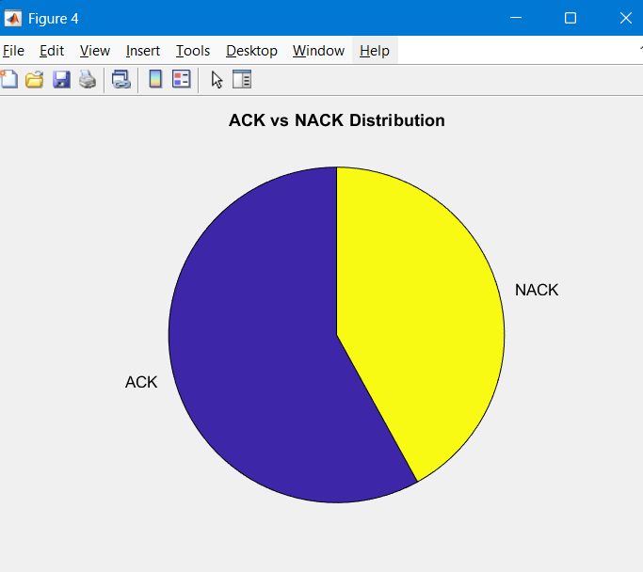
Figure 4: ACK vs NACK Distribution (Pie Chart)
- A summary of all transmissions:
  - Purple: ACKs (successes)
  - Yellow: NACKs (failures)
- Helps evaluate overall network reliability.
- A larger ACK slice = better performance.
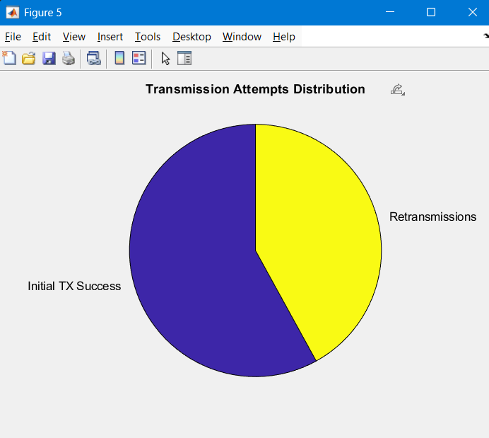
Figure 5: Transmission Attempts Distribution
- Pie chart showing:
  - Initial TX Success (no retransmission needed)
  - Retransmissions
- Indicates how many times UEs needed extra attempts to successfully deliver data.
- Useful for checking how well the HARQ and scheduling mechanisms are working.
Get Varying Results Through :
- Vary Number of UEs (User Equipments)

Expected Graph Difference:
- More collisions, retransmissions, and NACKs with higher number of UEs.
- Pie charts will show lower success ratio with more users.
- TTI bar graphs get denser and more colorful due to increased activity.

- Vary Simulation Time

Expected Graph Difference:
- Longer sim time = more data points on graphs.
- Pie chart proportions may stay similar, but total numbers grow

- Enable/Disable Adaptive MCS (if implemented)

Expected Graph Difference:
- With adaptive MCS, fewer retransmissions due to smarter modulation.
- Pie chart may show higher Initial TX Success.

- Select Scheduler Algorithm
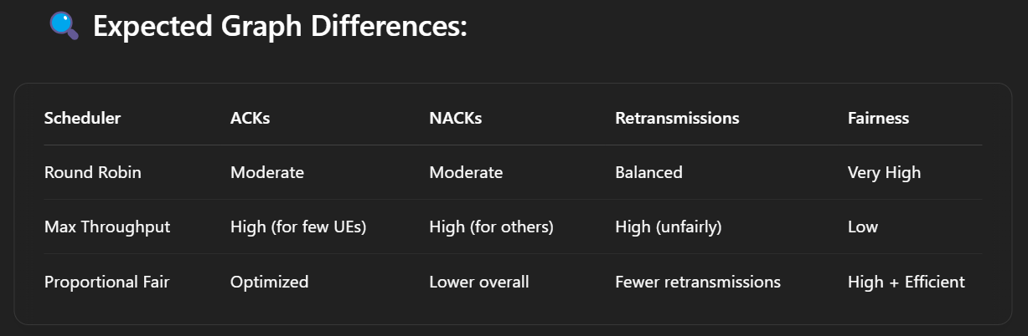

RESULTS ON MATLAB Command Panel:
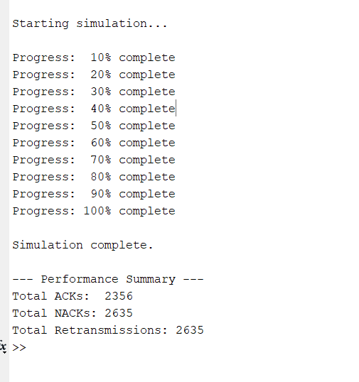

MAC PDU (Packet Format):
A MAC PDU (Protocol Data Unit) is the actual data packet created by the MAC layer that is sent over the physical layer to the receiver. It encapsulates user data and control information into a format that can be transmitted efficiently.

MAC PDU – Key Functions
- Carries data from higher layers (RLC).
- Multiplexes multiple logical channels (user + control).
- Includes MAC Control Elements (e.g., BSR, PHR).
- Supports HARQ retransmissions.
- Adds padding if needed.
- Formatted for PHY layer transmission.
Contents of a MAC PDU:
RLC Data (user traffic)
MAC *CE: Buffer Status Report
MAC CE: HARQ Feedback
Padding bytes

*CE – CONTROL ELEMENT

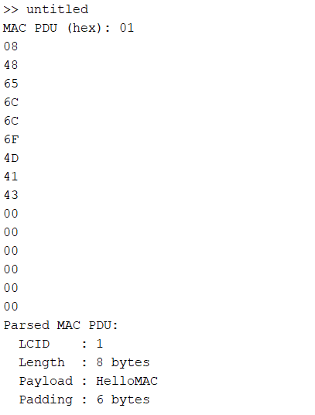

MAC Architecture Results:
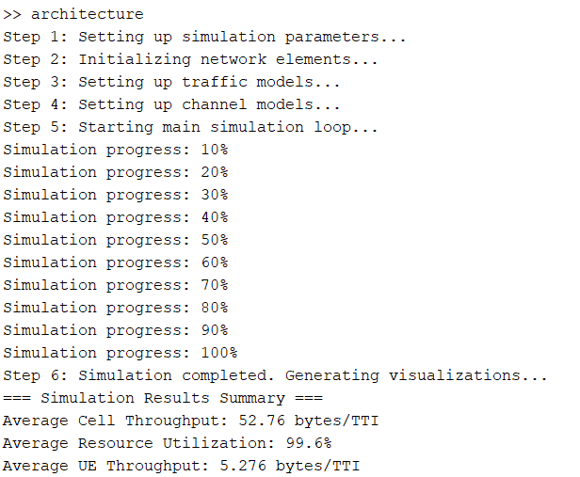

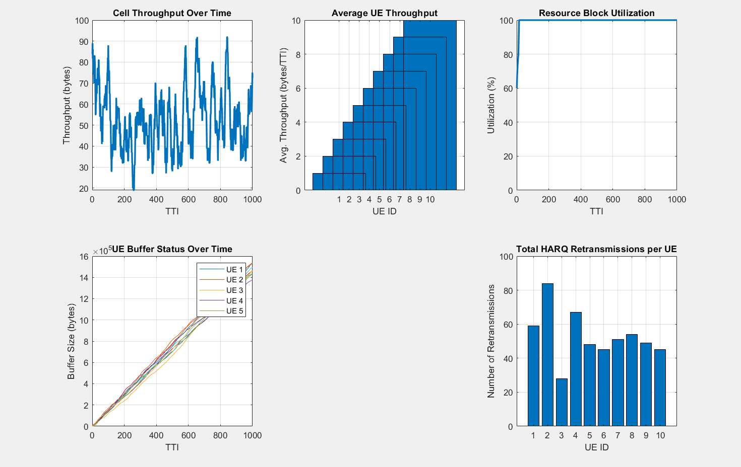
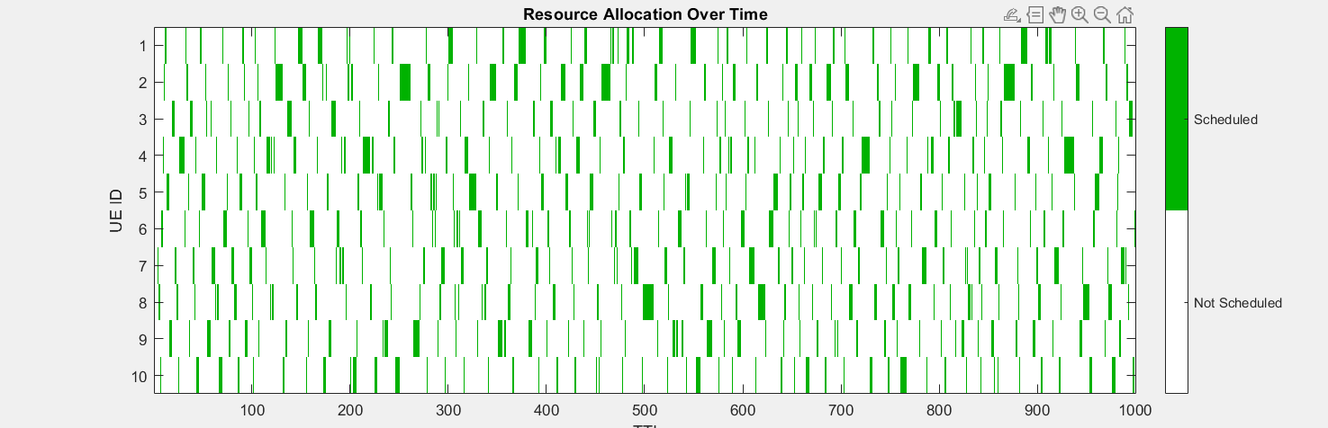
This MATLAB code simulates a simplified version of the 5G NR MAC layer over a number of Transmission Time Intervals (TTIs), modeling how user data is handled, scheduled, and transmitted from UEs (User Equipment) to the base station (gNB). The simulation incorporates realistic traffic models (Poisson, Full Buffer, and CBR), channel fading over time, dynamic HARQ retransmissions, and various scheduling algorithms (Round Robin, Max Throughput, Proportional Fair). During each TTI, new packets may arrive at UEs, buffer statuses are updated, resource blocks (PRBs) are allocated based on scheduling logic and channel quality, and packet transmissions are simulated. Performance metrics such as throughput, latency, buffer status, HARQ retransmissions, and resource utilization are calculated and visualized to evaluate network efficiency and fairness.

Varying results Can be Obtained Through Changing Parameters in the Code
A Table below Given To Help to Get the Desired Results.

Plot Title | Description |  | Computation Location |  | Influencing Parameters |  | Tuning Tips
1 |  | Cell Throughput |  | Total bytes successfully transmitted across all UEs per TTI |  | cellThroughput(t) in main loop |  | MCS, channel quality, PRB allocation, buffer size | Improve channel conditions, increase BWP, change scheduler
2 |  | UE Throughput |  | Average throughput per UE over time |  | throughputPerUE(ue, :) |  | Scheduler type, MCS, traffic model | Choose fairer scheduler, reduce UE load
3 |  | Resource Utilization |  | % of total PRBs used in each TTI |  | resourceUtilization(t) |  | BWP size, traffic load, MCS efficiency | Increase traffic, adjust BWP size, improve scheduling
4 |  | UE Buffer Status |  | Bytes waiting in each UE’s buffer over time |  | ueBufferStatus(ue, t) |  | Packet arrival rate, scheduling, HARQ success | Reduce arrival rate, improve channel, increase allocation
5 |  | HARQ Retransmissions |  | Count of failed transmissions needing retransmission |  | harqRetransmissions(ue, t) |  | Channel quality, MCS level, error model | Lower MCS level, improve channel conditions
6 |  | Resource Allocation Map |  | Which UEs were scheduled per TTI |  | scheduledUEs(ue, t) |  | Scheduler type, BSR reports | Modify scheduler policy (RR, PF, MT)

HARQ
- CQI doesn’t directly decide ACK or NACK.
- But it strongly influences which UE gets scheduled via the PF metric.
- Better CQI → higher PF metric → more scheduled transmissions → more chances to get ACKs.
- Over time, UEs with consistently higher CQI accumulate more successful transmissions (ACKs), while poor CQI UEs are scheduled less and may suffer more NACKs when they are.
- Once a UE is scheduled, it attempts a transmission.
- Whether it gets an ACK or NACK is decided randomly based on a probability ackProb

MATLAB Simulation:
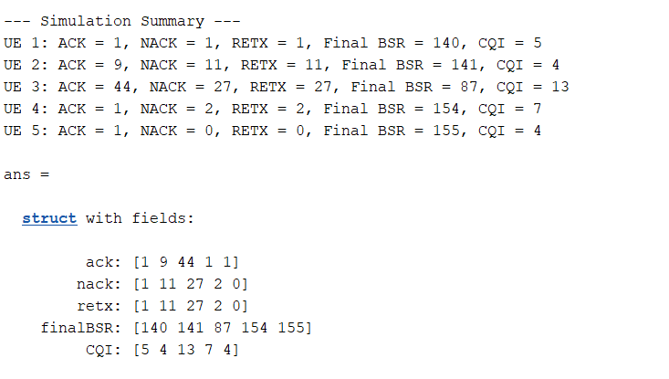

Graphs Generated:
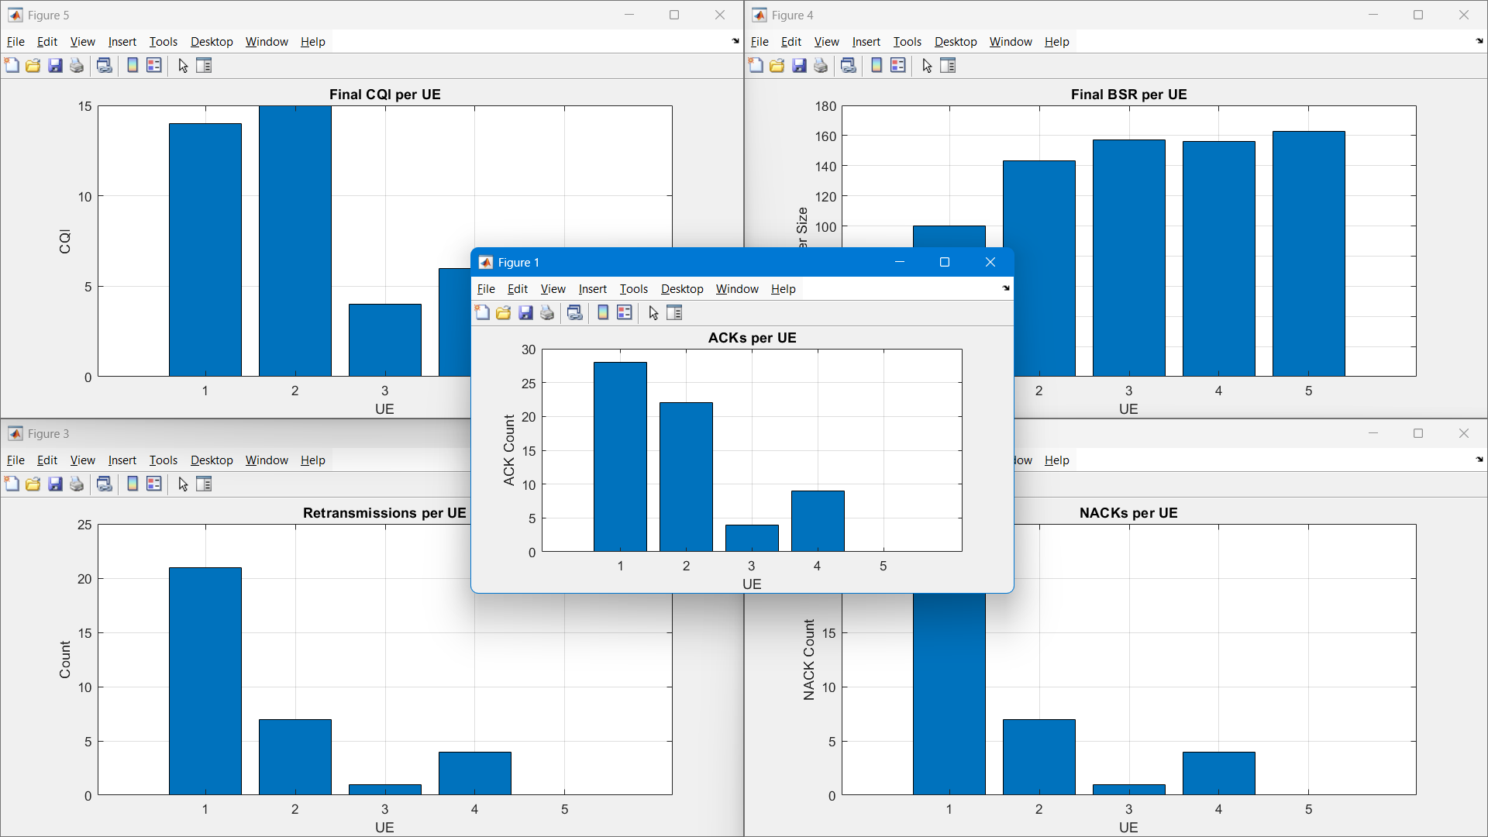

We Can Vary The Graphs By Changing Parameters.

Report by :

G. Santhosh Balaji 231CS224
T. Sai Nishnath Rao 231CS260
B. Mahi Tejesh Reddy 231CS216

